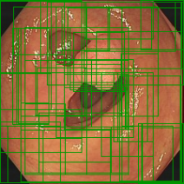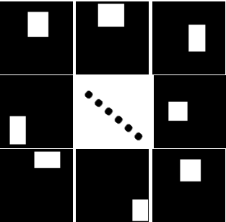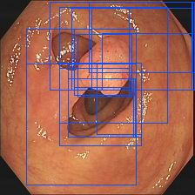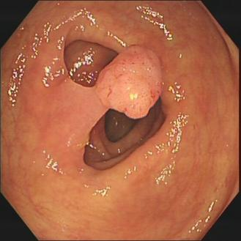

Featurex

Original Proposals

Selective

search

PraNet backbone



**Category threshold**

**Region threshold**

**Dual-threshold postprocessing**

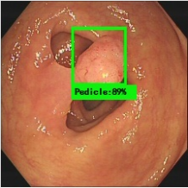

**...**

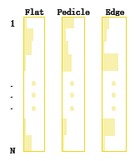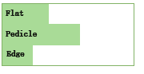

FC

FC



FC

Image-level scores

Softmax_d

**Multiple instance branch**

**...**

Conv_cls

Softmax_c

**Space category module**

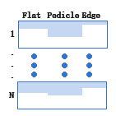

GAP

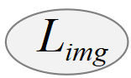

Pseudo segmentation map **P**

Proposals masks **B**

**Cross-referenced module**

Trained Proposal

Input Image **I**

Backbone

(VGG 16)

**RoI Pooling**